CPD module workbook

Psycho-social interventions

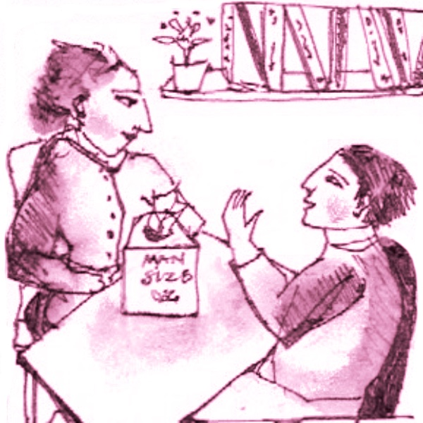

This module assumes you have completed the Talking to People module. You will find an elaboration of the skills you learned there in each of the topics. The orientation is one of dealing with the here and now, and the future, and getting on with the task of helping people change. As always you will be introduced to the available evidence to support your learning.

This is why we adopt a behavioural therapy approach.

This workbook has been designed for use in conjunction with
result4addiction. It will take you to the relevant content in the website. You can download the workbook from the website.

Contents

Read this guidance before you start 3
Key to icons 3
Topic One: applying motivational interviewing 4
Task 1 - From the What About Motivation page… 4
Task 2 - The Debating Box 5
Task 3 - Your Study Group 7
Topic Two: social behaviour and networking 8
Task 1 - From the Structured Treatment page… 8
Task 2 - The Debating Box 9
Task 3 - Your Study Group 11
Topic Three: mutual aid and fellowships 12
Task 1 - From the Twelve Steps Movement page… 12
Task 2 - The Debating Box 13
Task 3 - Your Study Group 15
Topic Four: the place of brief interventions 16
Task 1 - From the How Good is Treatment page… 16
Task 2 - The Debating Box 17
Task 3 - Your Study Group 19
Now try the Psycho-social module Quiz… 20

Read this guidance before you start

There are 4 topics in this module:
- Applying motivational interviewing
- Using a social behaviour and networking intervention
- Mutual aid and fellowships
- Brief interventions
You can work through the topics at your own pace, however, to keep up a momentum we suggest spending two weeks on each. Each topic has a variety of tasks (see icons below): watching videos, reading scientific articles, taking in checklists, for example.

Use the workbook to navigate the four topics. Be sure to add your reflections in the spaces provided. When you have completed the module, you can save the workbook as a digital record or download a hard copy of your work.

Ideally you will convene, or join, a Study Group (this could be a peer group, just one colleague, or a trusted supervisor) for your topic discussions. Arrange your meeting times right away and use these as the deadline for completion of each topic. The aim of the Study Group is to sharpen up your thoughts.

Key to icons

  - This is a task where you are asked to reflect on a question.

  - This task takes you to a page in the website and points to the essential reading.
  - The Debating Box flags up a controversial current issue and invites your reflections.
  - At the end of each topic you should meet with your study group and review what you have studied.
  - This is where you write down your thoughts and plans.
  - This indicates an open access article – one that is free to view and download.
  - This indicates an article where you must pay to view or access via your institution.

  - Please note that you should scroll through the document or click if you want to jump to the next place to enter your reflections.

Topic One: applying motivational interviewing
1

Knowing your service user’s motivation is the key to deciding where to start your intervention. Throughout this topic think about: i) why is motivation important? ii) how to assess motivation in relation to substance use? iii) what are the implications of those assessments? iv) how do you apply the results of your assessments to your treatment planning and review?

Task 1 - From the What About Motivation page…

- Watch the video of Professor Carlo DiClemente and take careful note of his emphasis on the need absolutely to listen to your service user in order to match your intervention to where they are at. Memorise his checklist.
- Watch the video of Professor Bill Miller and notice how he builds on Carlo DiClemente’s emphasis on the processes of change and the importance of structure and focus. Memorise his checklist.
- At the bottom of the page go to the Key Findings and read through any research articles that interest you.

Go to the What About Motivation page in result4addiction

What are the three most important things for you to take away from this task that will guide your practice? You can edit this section as often as you want.

Click or tap here to enter text.

Task 2 - The Debating Box

The Motion: Motivating people to change can only happen on a one-to-one basis

For….
Motivation to change is internally located in each individual and made up of a balance of pros and cons, for and against continuing a particular behaviour; shifting the balance in favour of change requires an accurately targeted individually focussed intervention.

Against…
Motivation to change can be externally inspired. Surrounding the focal person with people who apply pressure to change, or people who encourage change through their expectations, or offering the chance of a better quality of life is the best way to promote motivation to change.

Intuitively it makes sense that any intervention should take account of a person’s motivational state. For example, if somebody has decided that they really want to stop using drugs it would be counterproductive to start therapy designed to motivate them to change. However, it has proved difficult to find evidence for the presumption that matching treatment with motivation is important.

Katie Witkiewitz and her colleagues applied some sophisticated statistical analyses to assess the matching hypotheses of Project Match in the United States and did find support for the idea. Read this commentary…

Tober G (2010) Commentary: Evidence for matching — at last. Addiction 105: 1414–1415 doi.org/10.1111/j.1360-0443.2010.03026.x

There is a summary of the commentary on the next page…

Summary - Motivation Matters

In her commentary Gillian Tober highlights three things that practitioners know even if some of the evidence is lacking…

- It is important accurately to assess motivation in order to start an intervention at the right place, and then keep checking motivation throughout the intervention. People may be motivated to change one thing, for example not driving while intoxicated, but not motivated to stop drinking.
- Ignoring service user motivation to change suggests a lack of empathy, that is not understanding where the service user is at, and so risks them dropping out. Also understand an individual’s sources of motivation, which may be many and varied.
- There is no simple way to measure motivation for change either in research or clinical practice. It is about unravelling what the service user says.
Write down your thoughts on the importance of accurately assessing motivation in order to match to your intervention. You can edit this section as often as you want.

Click or tap here to enter text.

Task 3 - Your Study Group

Once you are happy that you have covered all the tasks, it’s time to go to your study group discussion. Here are some suggestions for structuring your discussion…

- How do you assess motivational state?
- How does motivational state alter the way you plan an intervention?
- How many ways can you think of to increase motivation for change?
- What is going to get in the way of increasing motivation?
Record your thoughts below. You can edit this section as often as you want.

Click or tap here to enter text.

Topic Two: social behaviour and networking
2

This topic is about helping people modify their motivation and behaviour with the help of a supportive social network. Social Behaviour and Network Therapy, SBNT, is a flexible, structured intervention that can be applied to most addiction problems. It is the first choice for addiction practitioners.

Task 1 - From the Structured Treatment page…

- Read through the Social Behaviour and Network Therapy manual.
- Go to the Addiction Recovery Questionnaire link and see how this can be used for treatment planning and measuring outcomes.
- Go to the take-home tasks link and see why these are important
- Go to the Key Findings at the bottom of the page and see the evidence for structured treatments.

Go to the Structured treatment page in result4addiction

What are the three most important things for you to take away from this task that will guide your practice? You can edit this section as often as you want.

Click or tap here to enter text.

Task 2 - The Debating Box

The Motion: Structured therapies are too rigid to be useful in the real world.
For…
For a variety of reasons service users tend not to stick to a planned programme and so it makes sense to let the therapy sessions evolve from one to the next. Doing this allows the therapist to individualise the focus of the intervention and respond to their service user’s changing needs.

Against…
Structure is about having a set of core components, not slavishly following a protocol. This means that the practitioner can set the agenda from an agreed understanding of where their service user is at and where they want to be. Without structure sessions commonly drift into aimless chat.

The point to underline about Social Behaviour and Network Therapy is that it can be used flexibly with most addiction problems. The article below highlights the need to be flexible in the application of structured interventions, particularly with hard-to-reach groups. It describes interviews with practitioners trained to deliver Motivational Enhancement Therapy and Social Behaviour and Network Therapy with looked-after children. There are different reasons that hard-to-reach groups are hard to reach, but what they have in common is that they are unsure that they want to be reached or actively avoid it. It is good to learn from the more extreme examples.

Alderson H, Brown R, Copello A, Kaner E, Tober G, Lingam R and McGovern R (2019) The key therapeutic factors needed to deliver behavioural change interventions to decrease risky substance use (drug and alcohol) for looked after children and care leavers: a qualitative exploration with young people, carers and front-line workers. BMC Medical Research Methodology 19, 38 doi.org/10.1186/s12874-019-0674-3

There is a summary of the key points on the next page…

Summary - Using structured treatments flexibly when and where service users feel comfortable

- The more damaged the relationships that a service user has, the harder for them to believe that practitioners will be helpful.
- Empathy, perseverance and providing both emotional and practical support which feels to be unconditional are paramount.
- Therapy sessions can be very practical, for example going for a walk or visiting a gallery, while discussing and planning the next steps.
- Substance misuse occurs in a wider context of risky behaviour and comorbidity which might be a more pressing concern for a service user and might best be the focus of the intervention.

Do you understand how to use Social Behaviour and Network Therapy in different situations? How might you apply SBNT in your practice? Write your thoughts below. You can edit this section as often as you want.

Click or tap here to enter text.

Task 3 - Your Study Group

Once you are happy that you have covered all the tasks, it’s time to go to your study group discussion. Here are some suggestions for structuring your discussion…

- Are you able to apply SBNT in your practice? If not, what is the best way for you to learn it?
- Do you have a selection of take-home tasks that you are familiar with?
- Are you clear who NOT to involve in a social support group?
- What kind of problems do you think will need a specialist intervention other than SBNT?

Record your thoughts below. You can edit this section as often as you want.

Click or tap here to enter text.

Topic Three: mutual aid and fellowships
3

This topic explores the role of non-professional, lived experience organisations in helping people recover from addiction and how you might help your service users access them.

Task 1 - From the Twelve Steps Movement page…

- Read through the page and learn about the 12-steps.
- Watch the two videos by Dr Brian Wells.
- Note the findings on the effectiveness of 12-step programmes.
- Note that there is a manual available to browse for Twelve Step Facilitation as an intervention.

Go to the 12 Steps Movement page in result4addiction

What are the three most important things for you to take away from this task that will guide your practice? You can edit this section as often as you want.

Click or tap here to enter text.

Task 2 - The Debating Box

The Motion: Mutual aid and fellowship support replace the need for treatment services

For…
Mutual aid meetings are available 24/7, are free and conditional only on participants wishing to change their addiction problem in some way. Meetings are more flexible and more widely available than addiction services. There are no time limits and support can be there throughout the lifespan.

Against…
Mutual aid groups are very important and, indeed, provide a kind of DIY Social Behaviour and Network Therapy. However, a lot of problem drinkers and drug takers have complicated medical and psychological conditions that require someone who knows how to treat these aspects of addiction.

The level of involvement with mutual aid groups in the UK contrasts with the United States where 12-step programmes in particular are much more deeply embedded in society and where, perhaps, the population as a whole has a greater interest in spirituality.

The study below reports on the attitudes of UK addiction practitioners (n=364) toward AA and NA and the 12-step philosophy.
Day E, Gaston RL, Furlong E, Murali V and Copello A (2005) United Kingdom substance misuse treatment workers’ attitudes toward 12-step self-help groups. Journal of Substance Abuse Treatment 29: 321–327 doi:10.1016/j.jsat.2005.08.009

.

There is a summary of the key findings on the next page…

Summary - attitudes of addiction practitioners in the UK to 12-step programmes

When asked to estimate the percentage of their clients who attend either AA or NA, the response was an average of 10.6%. This figure was lowest for workers who only treated primary drug users, mean 3.5%, and higher for those treating just primary alcohol user, mean 10.4%.

39%
said they felt positive about AA and NA meetings.

33%
had attended at least one AA or NA meeting.

33%
said that they thought their service users were suitable for an AA or NA approach.

28%
said they were likely to suggest attending AA or NA.

What are your own thoughts about mutual aid groups? How might they be useful in your practice? You can edit this section as often as you want.

Click or tap here to enter text.

Task 3 - Your Study Group

Once you are happy that you have covered all the tasks, it’s time to go to your study group discussion. Here are some suggestions for structuring your discussion…

- Check out that you have understood what mutual aid groups do.
- Do you know how to get people involved in mutual aid locally?
- What are the different kinds of mutual aid?
- Do you understand how the key ingredients are similar to SBNT?

Write down your thoughts below. You can edit this section as often as you want.

Click or tap here to enter text.

Topic Four: the place of brief interventions
4

This topic is about the question of how much intervention is best. By “how much?” we mean how long should the intervention go on for, how frequently should sessions occur and how long should they last? Is there an ideal answer to all these questions? Given that so often, service users vote with their feet, it is worth taking some time to think about this and plan services accordingly.

Task 1 - From the How Good is Treatment page…

- Read the Good Outcome Predictor checklist - an indicator of how brief a treatment might be.
- Watch the Professor Rudi Moos video.
- Make sure you understand the four components of any treatment plan in the What is treatment like? section.
- Make sure you understand the range of interventions available and what they are for.

Go to the How Good is Treatment page in result4addiction

What are the three most important things for you to take away from this task that will guide your practice? You can edit this section as often as you want.

Click or tap here to enter text.

Task 2 - The Debating Box

The Motion: The briefer the intervention, the more skilled the practitioner needs to be.

For…
The majority of people with alcohol and drug problems do not visit specialist addiction services but are in contact with all sorts of other services eg general practice, pharmacy, dentists, ante-natal services. The skilled application of brief interventions is highly effective in these settings.

Against…
Brief interventions are generally opportunistic, meaning they occur outside specialist services. Practitioners do not need an addiction training as they already have the skills quickly to understand and assess problems and to deliver an effective brief intervention.

The point to be made here is that some people will move on from their addiction with only brief contact with professional help; these are most likely people who are already motivated to change and have the social capital that they need. Things do not always work out as expected and, as ever, therapists need to be alert to how well their intervention is going and be flexible in response.

It is best not to get bogged down with definitions, rather understand the principles.

You can browse the WHO alcohol brief intervention training manual on the next page…

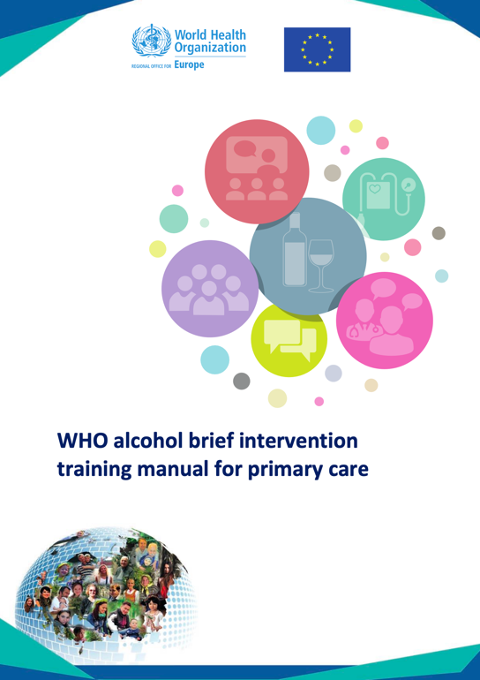
Summary

Browse the WHO alcohol brief intervention training manual for primary care (click on the image). The content refers to alcohol brief interventions but the same approach can be applied to drugs in most circumstances. This is a really excellent training guide - how much detail you want to read will depend on your role. Everybody will benefit from looking at these sections:

pp2-6 What are brief interventions

pp50-52 Practitioner concerns about their role

pp53-56 Beginning a conversation

pp57-66 Screening and feedback using the AUDIT

pp70-73 Eliciting change talk

What are your thoughts about brief interventions and how they might apply to your practice? You can edit this section as often as you want.

Click or tap here to enter text.

Task 3 - Your Study Group

Once you are happy that you have covered all the tasks, it’s time to go to your study group discussion. Here are some suggestions for structuring your discussion…

- Do you have a good understanding of the approach to treatment which places the service user at the heart of it?
- Are you clear what the various definitions of brief interventions are?
- Do you understand why the most skilled staff need to undertake the briefer interventions?

Record your thoughts below. You can edit this section as often as you want.

Click or tap here to enter text.

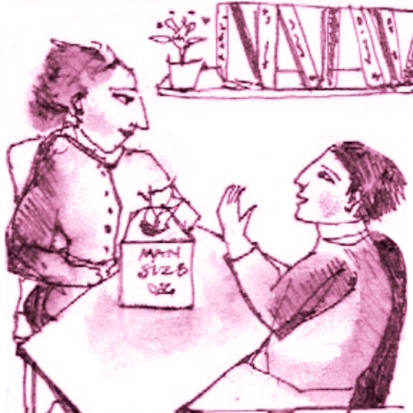

Now try the Psycho-social module Quiz…

The quiz is there solely for your use to see how much you have absorbed from the Psycho-social module – it is not a test or exam. You may find it useful to highlight things you want to go over again.

Go to the CPD Modules page in result4addiction to launch the quiz.

