CPD module workbook

Psycho-pharmacology

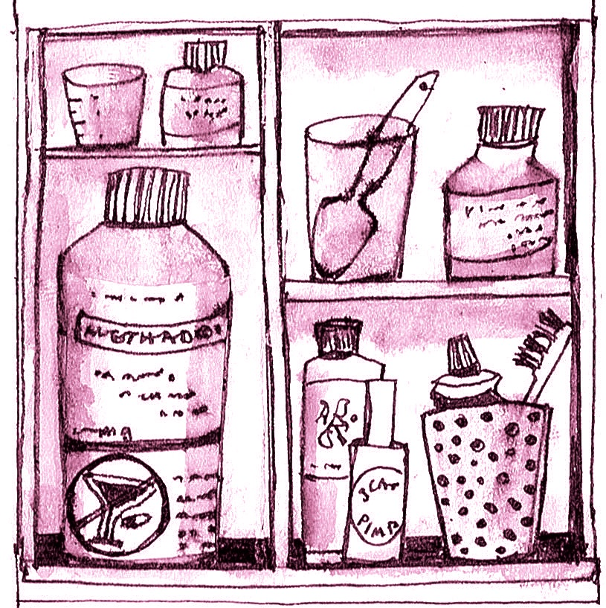

This module looks at how medicines and illicit drugs work and why they can be addictive. Connecting the pharmacology with the psychology of addiction is what makes this field of study so interesting.

You cannot prescribe your way out of an addiction problem but medications can be helpful along the recovery journey.

This workbook has been designed for use in conjunction with
result4addiction. It will take you to the relevant content in the website. You can download the workbook from the website.

Contents
Read this guidance before you start 3
Key to icons 3
Topic One: what is role of pharmacological interventions? 2
Task 1 - From the How Good is Treatment page… 2
Task 2 - The Debating Box 3
Task 3 - Your Study Group 5
Topic Two: why are drugs addictive? 6
Task 1 - From the Why are Drugs Addictive page… 6
Task 2 - The Debating Box 7
Task 3 - Your Study Group 9
Topic Three: how do psychoactive drugs work? 10
Task 1 - From the How do Psychoactive Drugs Work? page… 10
Task 2 - The Debating Box 11
Task 3 - Your Study Group 13
Topic Four: how good are pharmacotherapies? 14
Task 1 - Revisit the How Good is Treatment page… 14
Task 2 - The Debating Box 15
Task 3 - Your Study Group 17
Now try the Psycho-pharmacology Quiz… 18

Read this guidance before you start

There are 4 topics in this module:
- What is the role of pharmacotherapy?
- Why are drugs addictive?
- How do drugs (and medicines) work?
- How effective are pharmacotherapies?
You can work through the topics at your own pace, however, to keep up a momentum we suggest spending two weeks on each. Each topic has a variety of tasks (see icons below): watching videos, reading scientific articles, taking in checklists, for example.

Use the workbook to navigate the four topics. Be sure to add your reflections in the spaces provided. When you have completed the module, you can save the workbook as a digital record or download a hard copy of your work.

Ideally you will convene, or join, a Study Group (this could be a peer group, just one colleague, or a trusted supervisor) for your topic discussions. Arrange your meeting times right away and use these as the deadline for completion of each topic. The aim of the Study Group is to sharpen up your thoughts.

Key to icons

  - This is a task where you are asked to reflect on a question.
  - This task takes you to a page in the website and points to the essential reading.

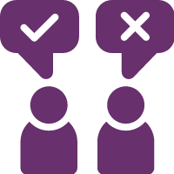
  - The Debating Box flags up a controversial current issue and invites your reflections.
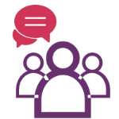
  - At the end of each topic you should meet with your study group and review what you have studied.
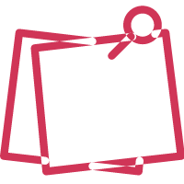
  - This is where you write down your thoughts and plans.
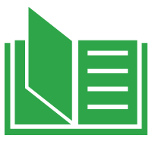
  - This indicates an open access article – one that is free to view and download.
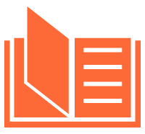
  - This indicates an article where you must pay to view or access via your institution.

  - Please note that you should scroll through the document or click if you want to jump to the next place to enter your reflections.

Topic One: what is role of pharmacological interventions?
1

We are starting this module by looking at how pharmacological interventions fit into an overall treatment plan.

Task 1 - From the How Good is Treatment page…

- Watch the video interview with Professor Rudi Moos who talks about the factors associated with a good outcome. Notice that these can be combined under the umbrella of social capital.
- Consider the four components of treatment and think about how pharmacotherapies can play a part in each of these.
- At the bottom of the page take note of the broad categories of pharmacotherapy.

Go to the How Good is Treatment page in result4addiction

What are the three most important things for you to take away from this task that will guide your practice? You can edit this section as often as you want.

Click or tap here to enter text.

Task 2 - The Debating Box

The Motion: Alcohol minimum pricing is the only way to reduce alcohol related harms

For…

There is a lot of evidence on how minimum pricing works to reduce alcohol consumption in the whole population. It is a policy that can easily be adjusted by politicians as needed and it makes clear to the drinks industry that they will not be allowed to sell whatever products they like to the public.

Against…

It is counter to basic freedoms to impose an alcohol policy that affects everybody when it is only a small proportion of drinkers who have any problems. The best solution is a medication so that individuals can control their own alcohol consumption and take responsibility for their health and wellbeing.

Read these articles. They are not intended to be compared directly, rather they point to two ways of achieving the same goal, namely a reduction in alcohol consumption. On the one hand a relatively inexpensive medication becomes costly when applied at a population level, on the other hand a social policy is going to affect everybody. Is there a preferred approach?

Aubin H-J, Dureau-Pournin C, Falissard B, Paille F, Rigaud A, Micon S, Pénichon M, Andersohn F, Truchi C, and Blin P on behalf of the USE-PACT study group (2021) Use of Nalmefene in Routine Practice: Results from a French Prospective Cohort Study and a National Database Analysis. Alcohol and Alcoholism 56: 545–555 doi.org/10.1093/alcalc/agab029

Wyper GMA, Mackay DF, Fraser C, Lewsey J, Robinson M, Beeston C et al (2023) Evaluating the impact of alcohol minimum unit pricing on deaths and hospitalisations in Scotland: a controlled interrupted time series study. The Lancet 401: 1361-1370 doi.org/10.1016/S0140-6736(23)00497-X

There is a summary of the key findings on the next page…

Summary

Minimum alcohol unit pricing policy
- Since May 1, 2018, every alcoholic drink sold in Scotland has had minimum unit pricing (MUP) of £0·50 per unit - Canada, Australia, Ireland have similar policies.
- Hospital admissions wholly attributable to alcohol reduced by 4.1%, and deaths by 13.4%. Hospitalisations for alcohol dependence increased 7.2% and intoxication 3.9%.
- The most disadvantaged people benefit most from minimum pricing. Alcohol deaths reduced 17-33% and hospitalisations 4-7% in the four most deprived groups.
Nalmefene - indicated for heavy drinkers
- A real-life study of nalmefene prescribing in France reports on 1year outcomes for 256 of 700 people newly prescribed nalmefene in routine practice - 46% in primary care.
- Reduction from baseline averaged 41.5gm/day (sd 57.4) and heavy drinking days by 10.7days/month (sd 11.7). At 1month 5% discontinued medication, 52% at 1year.
- Other studies have shown nalmefene is cost-effective and significantly reduces adverse alcohol related diseases and deaths.
Write down your thoughts on the use of pharmacotherapies to support public health goals. You can edit this section as often as you want.

Click or tap here to enter text.

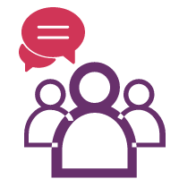
Task 3 - Your Study Group

Once you are happy that you have covered all the tasks, it’s time to go to your study group discussion. Here are some suggestions for structuring your discussion…

- Can you compensate for a paucity of social capital by giving more support with medication?
- In broad brush terms what are the goals of different categories of pharmacotherapy?
- Can medication help with lifestyle change?
- Is medication or public fiscal policy the better preventive measure?
Record your thoughts below. You can edit this section as often as you want.

Click or tap here to enter text.

Topic Two: why are drugs addictive?
2

This topic is about the connections between the pharmacological properties of a drug and the psychology of addiction. This applies equally to medicinal and recreational drugs.

Task 1 - From the Why are Drugs Addictive page…

- Read through the brief account of the properties of drugs that make them more or less addictive.
- Watch Duncan Raistrick’s slide show. Allow plenty of time to do this and be sure that you have understood what it is about drugs that makes them addictive, what is positive and negative reinforcement, and how to apply the principles in practice.

Go to the Why are Drugs Addictive page in result4addiction

What are the three most important things for you to take away from this task that will guide your practice? You can edit this section as often as you want.

Click or tap here to enter text.

Task 2 - The Debating Box

The Motion: Categorical diagnostic data are the backbone of good prescribing practice

For…
The most useful single piece of information about anybody with any health problem is to know, at least in broad brush terms, what is wrong with them. Not only does this determine the therapy that is needed, the likely outcome, and the therapy setting, but also provides an essential national statistic.

Against…
Everybody is different and it is damaging to try and place people in a box which then means that they get a therapy they did not want and is not appropriate. Collecting data to feed into agency or national statistics is not in service users’ best interests and gives a false impression of a scientific approach.

Medications are licensed for use to treat specified disorders or conditions. Prescribers should have specialist training before they think of deviating from the given indications of a medication. The World Health Organisation maintains the ICD as a reference guide to every disease and disorder recognised by health care professionals. It is a useful guide for prescribers.

Browse the addictions section of the ICD-11 website.
World Health Organisation International Classification of Diseases and Disorders ICD-11

The ICD is a handy reference describing the nature of addiction and related harms. The descriptions of disorders, such as addiction problems and mental health problems, are useful pegs around which practitioners can build a full picture of a person’s substance use. So, a familiarity with ICD is useful beyond the needs of prescribers.

There is a summary of the key uses of ICD on the next page…

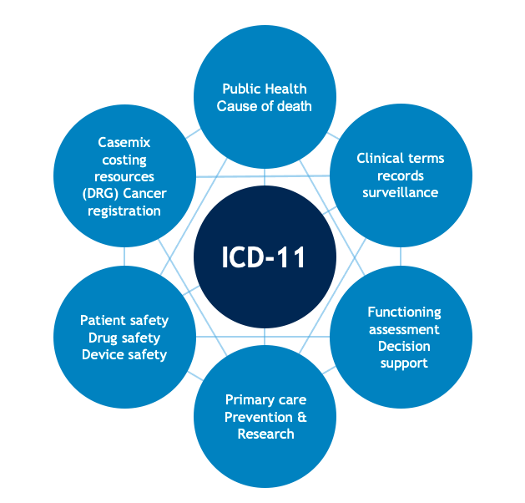
Summary

The WHO states the prime purpose of the ICD is to create systematic recording, analysis, interpretation and comparison of health care data collected in different countries or regions and at different times.

It is compiled by consensus of an international panel and is now in its 11th revision. The UK government uses ICD-11 for health care statistics. This is how WHO summarises its uses…

Did you find the descriptions in ICD useful and easy to understand? Does ICD help your understanding of the place of medication? Can you see more general uses of ICD? Write your thoughts below. You can edit this section as often as you want.

Click or tap here to enter text.

Task 3 - Your Study Group

Once you are happy that you have covered all the tasks, it’s time to go to your study group discussion. Here are some suggestions for structuring your discussion…

- Have you understood what makes some drugs addictive?
- Is an internationally recognised categorisation of problems useful i) in practice ii) for statistical data?
- How might you use ICD-11 in your own practice/agency?

Record your thoughts below. You can edit this section as often as you want.

Click or tap here to enter text.

Topic Three: how do psychoactive drugs work?
3

This topic is at the heart of understanding people’s experiences of taking drugs or psychoactive medications. Practitioners can apply the principles described here to make rational prescribing and treatment planning decisions.

Task 1 - From the How do Psychoactive Drugs Work? page…

- Take note of the basics of how neurones and receptors work and watch the Mouse Party video.
- Watch Duncan Raistrick’s slide show about how drugs work. There is more detail about receptors which are the core of this topic. Allow plenty of time for this and get a feel for how different drugs trigger different receptors. Check out that you are familiar with all the drug effects.
- Watch Duncan Raistrick’s slide show about drug harms and harm reduction. Allow plenty of time to appreciate all the harms caused by substance misuse and note the suggested harm reduction strategies.

Go to the How Do Drugs Work page in result4addiction
What are the three most important things to take away from this task that will guide your practice? You can edit this section as often as you want.

Click or tap here to enter text.

Task 2 - The Debating Box

The Motion: Drug consumption rooms should be available to everybody with an addiction problem

For…
Drug consumption rooms are a form of harm reduction. Harm reduction is important at all stages of the recovery journey. To be able to take drugs in a safe environment, especially if there is also some access to basic health care, is a significant step in preventing serious consequences and costs from drug use.

Against…
Providing drug users with a safe place to take drugs and some guidance on using may make motivating for change more difficult. The general public object to tax-payers money being spent on expensive units which are seen to encourage continued drug use and drug dealing around the facility.

Any discussion of substance use related harms begs the question ‘Can the harm be reduced?’ Harm reduction tends to be controversial because the balance between the benefits and the disadvantages is often unclear. Read this article which reviews the evidence for supervised injecting facilities and drug consumption rooms and see what general principles for judging a harm reduction strategy you can draw out.
Tran V, Reid SE, Roxburgh A and Day CA (2021) Assessing Drug Consumption Rooms and Longer Term (5 Year) Impacts on Community and Clients. Risk Management and Healthcare Policy 14: 4639-4647
doi.org/10.2147/RMHP.S244720

There is a summary of the key findings on the next page…

Summary

The researchers report on i) drug-related harms, ii) access to substance use treatment and other health services, iii) impact on the local drug injecting population, iv) impact on public drug use, drug-related crime and violence. There has not been a cost-effectiveness analysis.

Health outcomes from a 5yr perspective
A 35% decrease in ambulance attendances for opioid related problems (there was a general decrease in the area but not so marked). An increase from 38% to 61% experiencing an overdose, and a 7% increase in those injecting daily. 32% more engaged with drug treatment services and 40% more with primary health care. 48% were getting health care for the first time. 77% had at least one period of stopping injecting.

Community outcomes from a 5yr perspective
Witnessing injecting in the community was reported down from 33% to 19% by local residents and 38% to 28% for businesses. There was a corresponding reduction in discarded drug use paraphernalia but no reduction in the offers to buy street drugs.

What are your own thoughts about injecting rooms? Can you think of some harm reduction strategies with minimal downsides? You can edit this section as often as you want.

Click or tap here to enter text.

Task 3 - Your Study Group

Once you are happy that you have covered all the tasks, it’s time to go to your study group discussion. Here are some suggestions for structuring your discussion…

- Check out that you have understood what receptors are.
- Looking at what different transmitters do, what general principles can you see?
- What harm reduction strategies are relevant to your area of work?
- How far can harm reduction strategies go?

Write down your thoughts below. You can edit this section as often as you want.

Click or tap here to enter text.

Topic Four: how good are pharmacotherapies?
4

There is a lot to take in from this topic which is about the role of pharmacotherapies and also the outcomes from specific medications. It will be clear at this stage of the module that pharmacotherapies are rarely meant to be used on their own, rather they supplement psychosocial interventions: the effectiveness of medications needs to be read in this context.

Task 1 - Revisit the How Good is Treatment page…

- When you visited this page from Topic One you were looking at the role of pharmacotherapies at different points in recovery. You might want to refresh your memory.
- Go to the prescribing interventions and be sure you have a good understanding of these main categories.
- At the bottom of each page you can read about the evidence for the treatment, including pharmacotherapies, of specific substance misuse problems.

Revisit the How Good is Treatment page in result4addiction

What are the three most important things for you to take away from this task that will guide your practice? You can edit this section as often as you want.

Click or tap here to enter text.

Task 2 - The Debating Box

The Motion: Psychoactive drugs should be available over the counter

For…
Over the counter drugs are labelled according to pharmaceutical content and dose. They are safer than drugs bought in the illicit market, and so the risk of poisoning and potentially fatal overdose is reduced. Similarly, prescription-only drugs push people towards the illicit market.

Against…
By definition, psychoactive drugs are addictive and, without strict controls, people will slip into taking cocktails of drugs without heeding the cautions on the packaging, ending up with accidental overdoses and possibly death. An over-the-counter market incentivises sales rather than access to help.

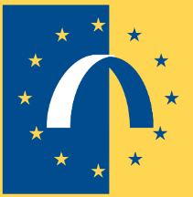
The European Monitoring Centre for Drugs and Drug Addiction
(EMCDDA) produces informative reports about what is happening to substance use, particularly in Europe. Have a look through this report which offers some insights into which drugs, prescribed or otherwise, are causing emergencies serious enough for people to end up in hospital Emergency Rooms. The findings reflect the well-known principle that the more available a drug or medication then the more likely that it will be misused and the more likely that there will be related problems.

EMCDD (2020) Drug-related hospital emergency presentations in Europe: update from the Euro-DEN Plus network View PDF

The report collated data from sentinel European Emergency Rooms for the period 2014-2017.

There is a summary of the key findings on the next page…

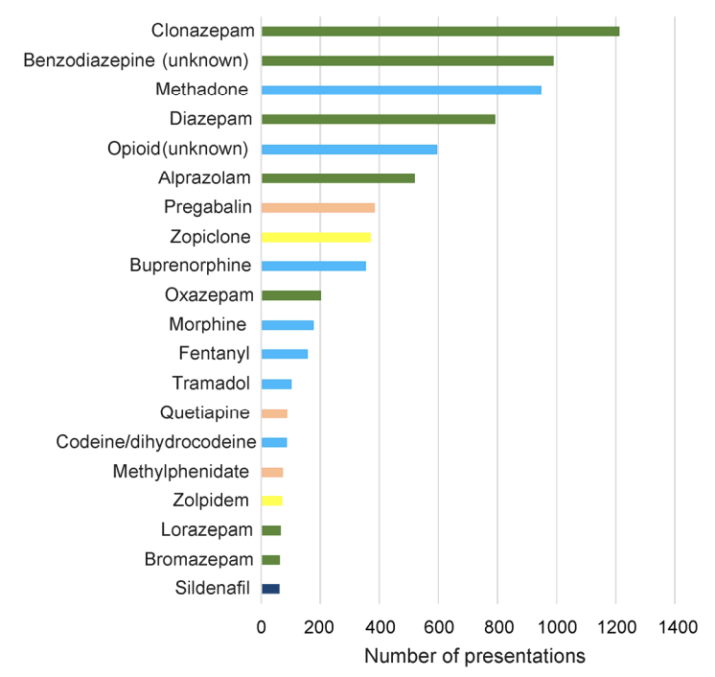
Summary

There were 23,947 acute drug toxicity presentations, excluding alcohol, typically representing less than 1% of Emergency Room attendances. The main drug involved tended to reflect the prevalence of use by different age groups.

Alcohol was frequently used with illicit drugs, especially cocaine.

There were 101 deaths.
A proportion of attendances were due to prescription drugs.

A quarter of all presentations involved at least one prescription drug, and of these, half, 12%, were prescription only drugs. The chart shows the medications most frequently involved.

What are your thoughts on which, if any, drugs should be restricted and which should be freely available? You can edit this section as often as you want.

Click or tap here to enter text.

Task 3 - Your Study Group

Once you are happy that you have covered all the tasks, it’s time to go to your study group discussion. Here are some suggestions for structuring your discussion…

- Are you clear when there is a role for medications?
- Do you understand why withdrawal from different drugs differs so greatly?
- Are the outcomes from prescribing what you expected?
- Which areas of your practice could benefit from more or from less prescribing?

Record your thoughts below. You can edit this section as often as you want.

Click or tap here to enter text.

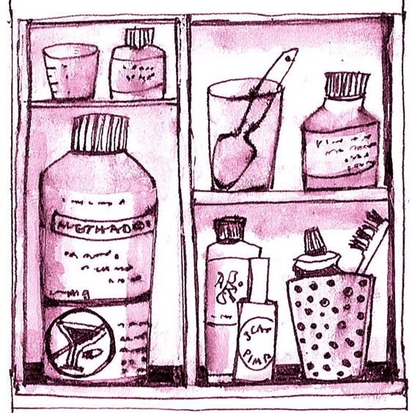

Now try the Psycho-pharmacology Quiz…

The quiz is there solely for your use to see how much you have absorbed from the Psycho-pharmacology module – it is not a test or exam. You may find it useful to highlight things you want to go over again.

Go to the CPD Modules page in result4addiction to launch the quiz.

